ISUBid Supplier Bid Response Guide

Available Bids
The Available Bids Tab will open after logging into ISUBid. Both “My Invitations” and “Other Bid Opportunities” will be displayed. Click the bid number to view the bid you are interested in.
Note: from here there are also tabs available to view Closed Bids, My Responses and My Awards.
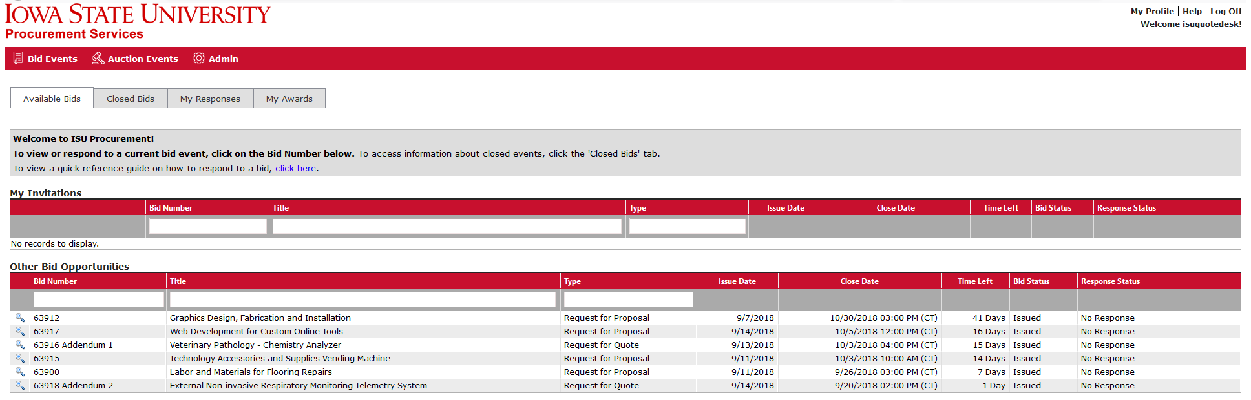

The following tabs will display after selecting the bid.
Note: If one or more tabs is not present on the selected bid, then it is not applicable to that solicitation.
Event Details Tab
Review bid information including Issue Date, Close Date, Bid Notes, Question Cutoff Date, and Bid Contact Information.

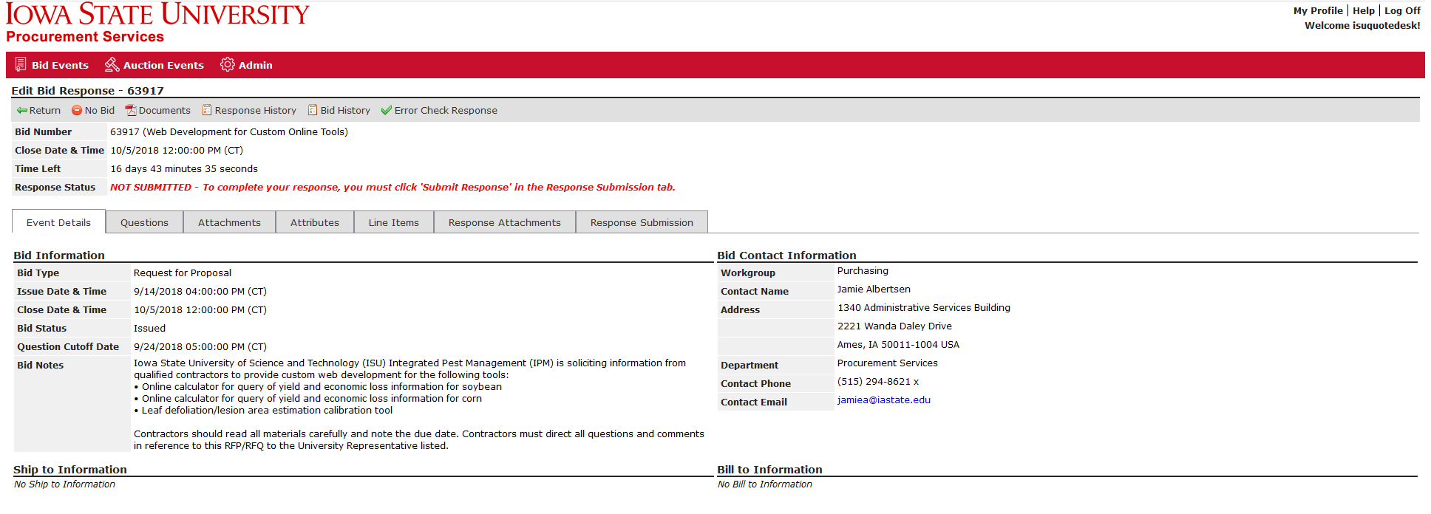

Messages Tab
View messages specific to the bid request. This tab may not appear.

Questions Tab
Allows for the submittal of bid specific questions up until the specified Cutoff Date and Time. Click on to submit a question. This tab may not appear if the buyer is not allowing questions.

Activities Tab
Review and respond to bid related activities. Activities will be one of the following types:
- Participation Activity – requires supplier involvement, for example: Attend a pre-proposal meeting
- Non-Participation Activity – provided for informational purposes only
- Intent Activity – requires supplier to indicate intent to respond to the bid

Attachments Tab
Attachments are used to provide additional information about the bid and/or to provide the supplier a form to complete and submit as a response attachment. Click to open and save the file to your computer.

Attributes Tab
Attributes allow the buyer to get additional information by asking specific questions. A supplier should read and/or answer all attributes. Required attributes will have a red asterisk (*) to the right of the required field and must be answered in order to submit a response. Click to save your responses. Click to determine if you missed any required responses.
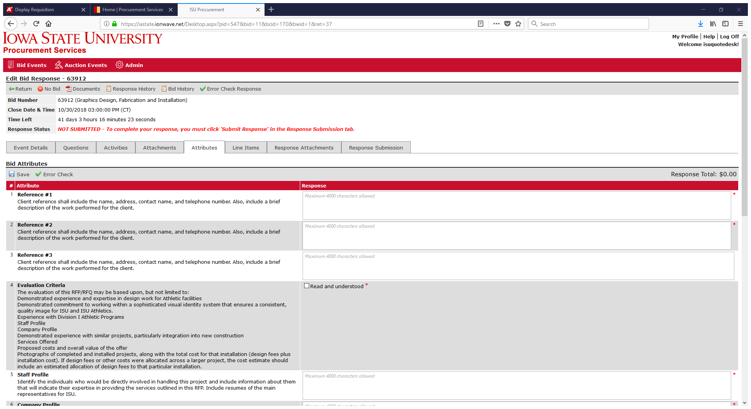

Line Items Tab
Bid line items are used to request pricing for a specification. Enter your price (or percentage) in the field provided. An extended price will be calculated when saved. Required line items will have a red asterisk (*) to the right of the required field and must be answered in order to submit a response. Click to save your responses. Click to determine if you missed any required price fields.
A line item may include any of the following options:
- Add Alternate – Click to bid an alternate. Only available if the buyer is allowing alternate bids.
- No Bid -- Clickto “no bid” at the line level.
- Add Notes – Click to enter notes or comments for buyer review.
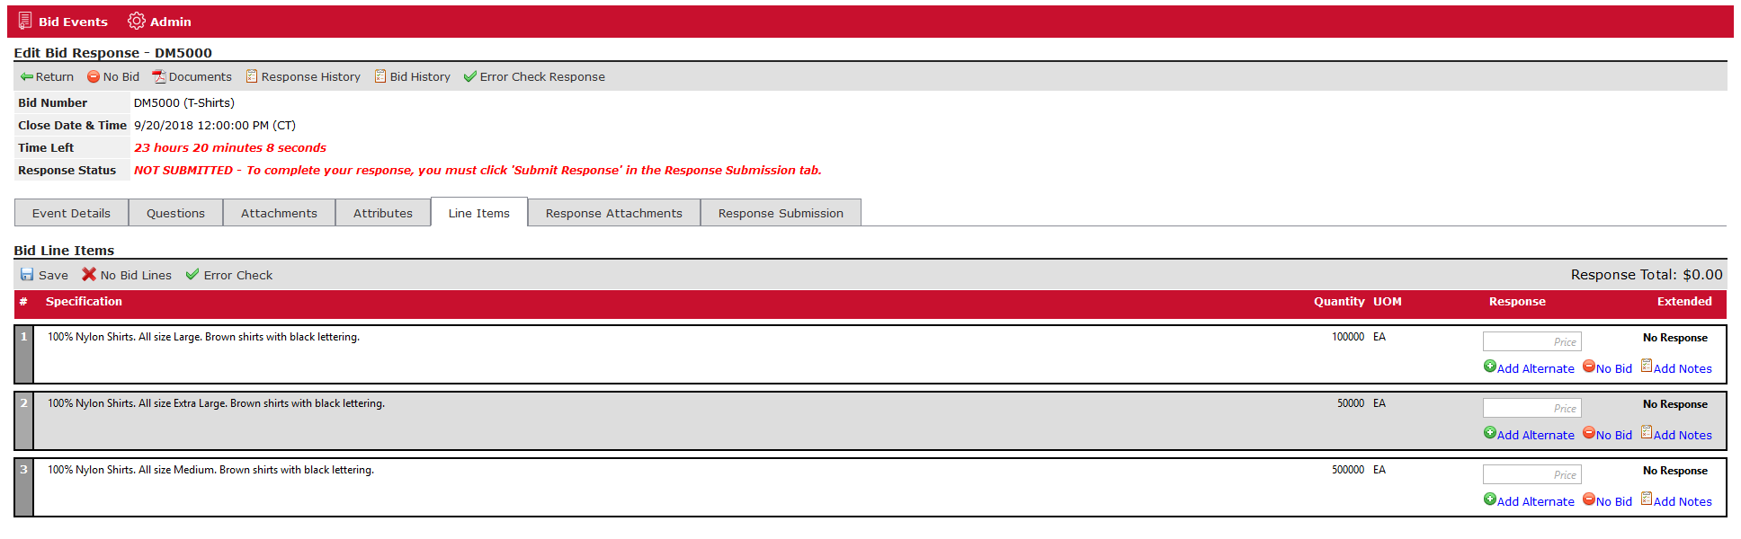
Response Attachments Tab
The Response Attachments tab specifies what documents the supplier is to provide as part of their response. Response attachments can be “Requested” or “Optional”. Required response attachments will have a red asterisk (*) next to the file name and must be attached in order to submit a response. Clickto upload the attachment. In the pop-up window click “Select File”, then highlight the file to be attached and click “Open” to select it, then enter a “Description” and click “Save” within the pop-up window. Click on the Response Attachments tab to save your attachments. Click to determine if you missed any required response attachments. The maximum file size is 100 megabytes per file.

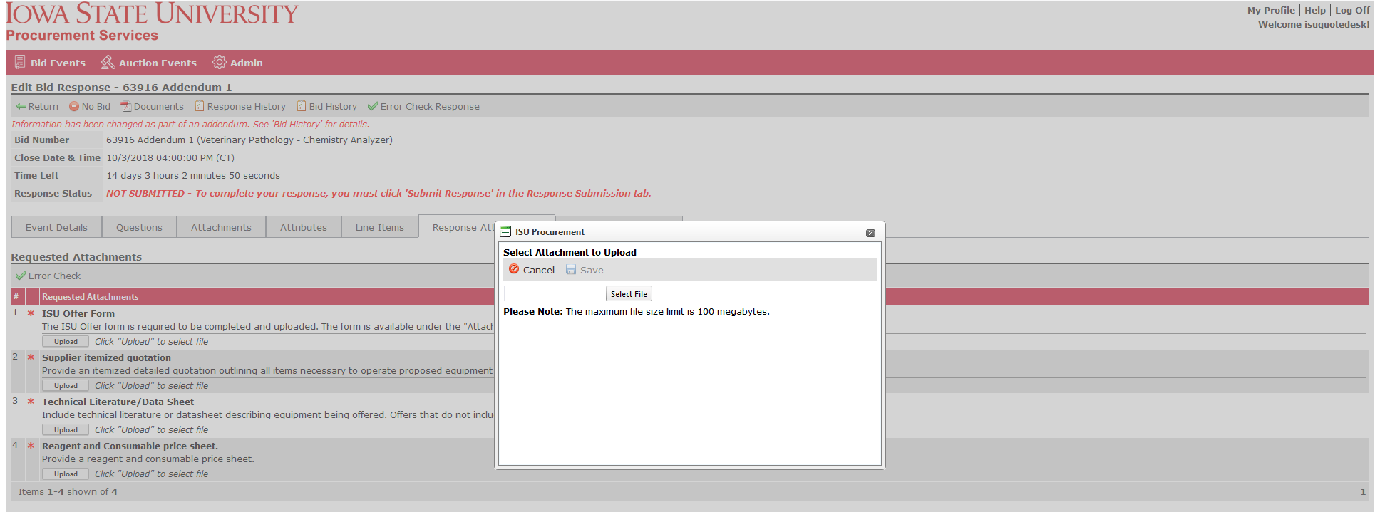

Note: The Download button located to the left of the file name allows you to view the attachment. The Delete button located to the right of the file name allows you to remove the attachment.
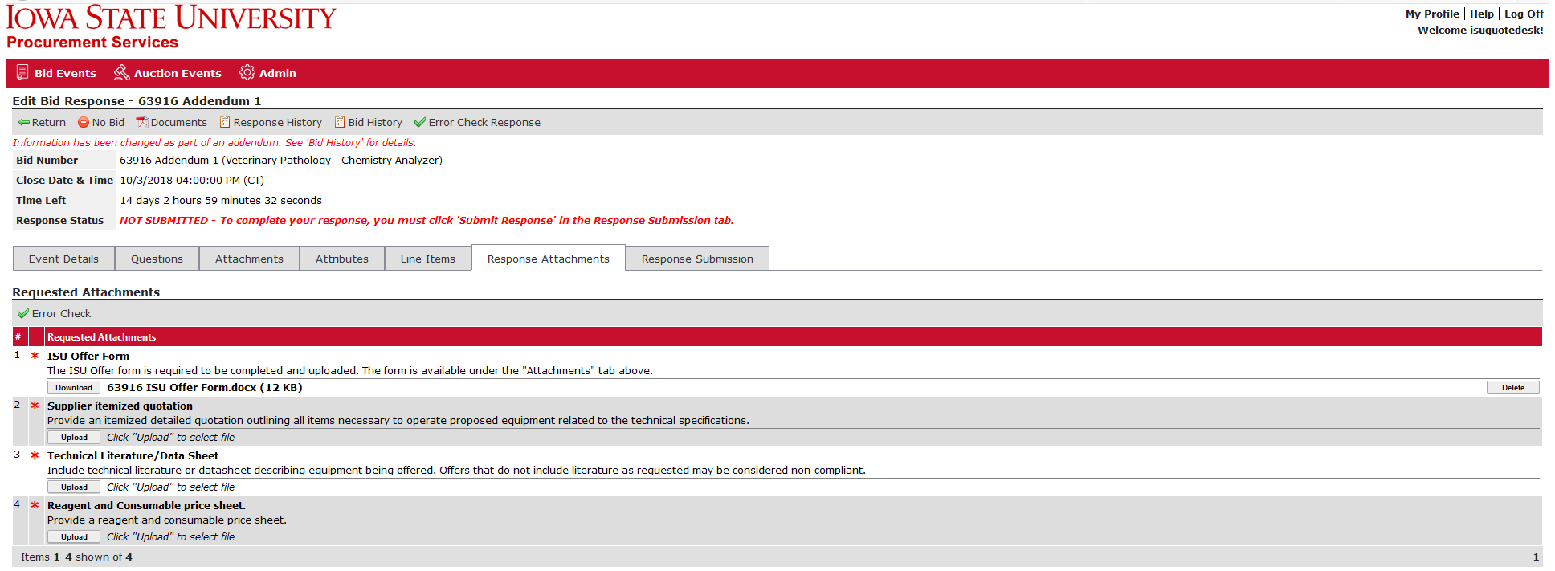

Response Submission Tab
You must successfully submit your bid response before the bid close date and time.
- Supplier Note to Buyer – Enter an optional note to the buyer. This field may not be available on some bids.
- Digital Signature – Enter “Your Full Name” and “Your Email Address”. Both are required.
Click to save your entries. Click to determine if you missed any required items needed to submit the bid.
Click to submit your response.

Submission Errors
If there are any errors, they will display on the Response Submission tab. The error message will indicate which tab(s) the error(s) are on. An email notification will be sent to confirm the failed response submission.

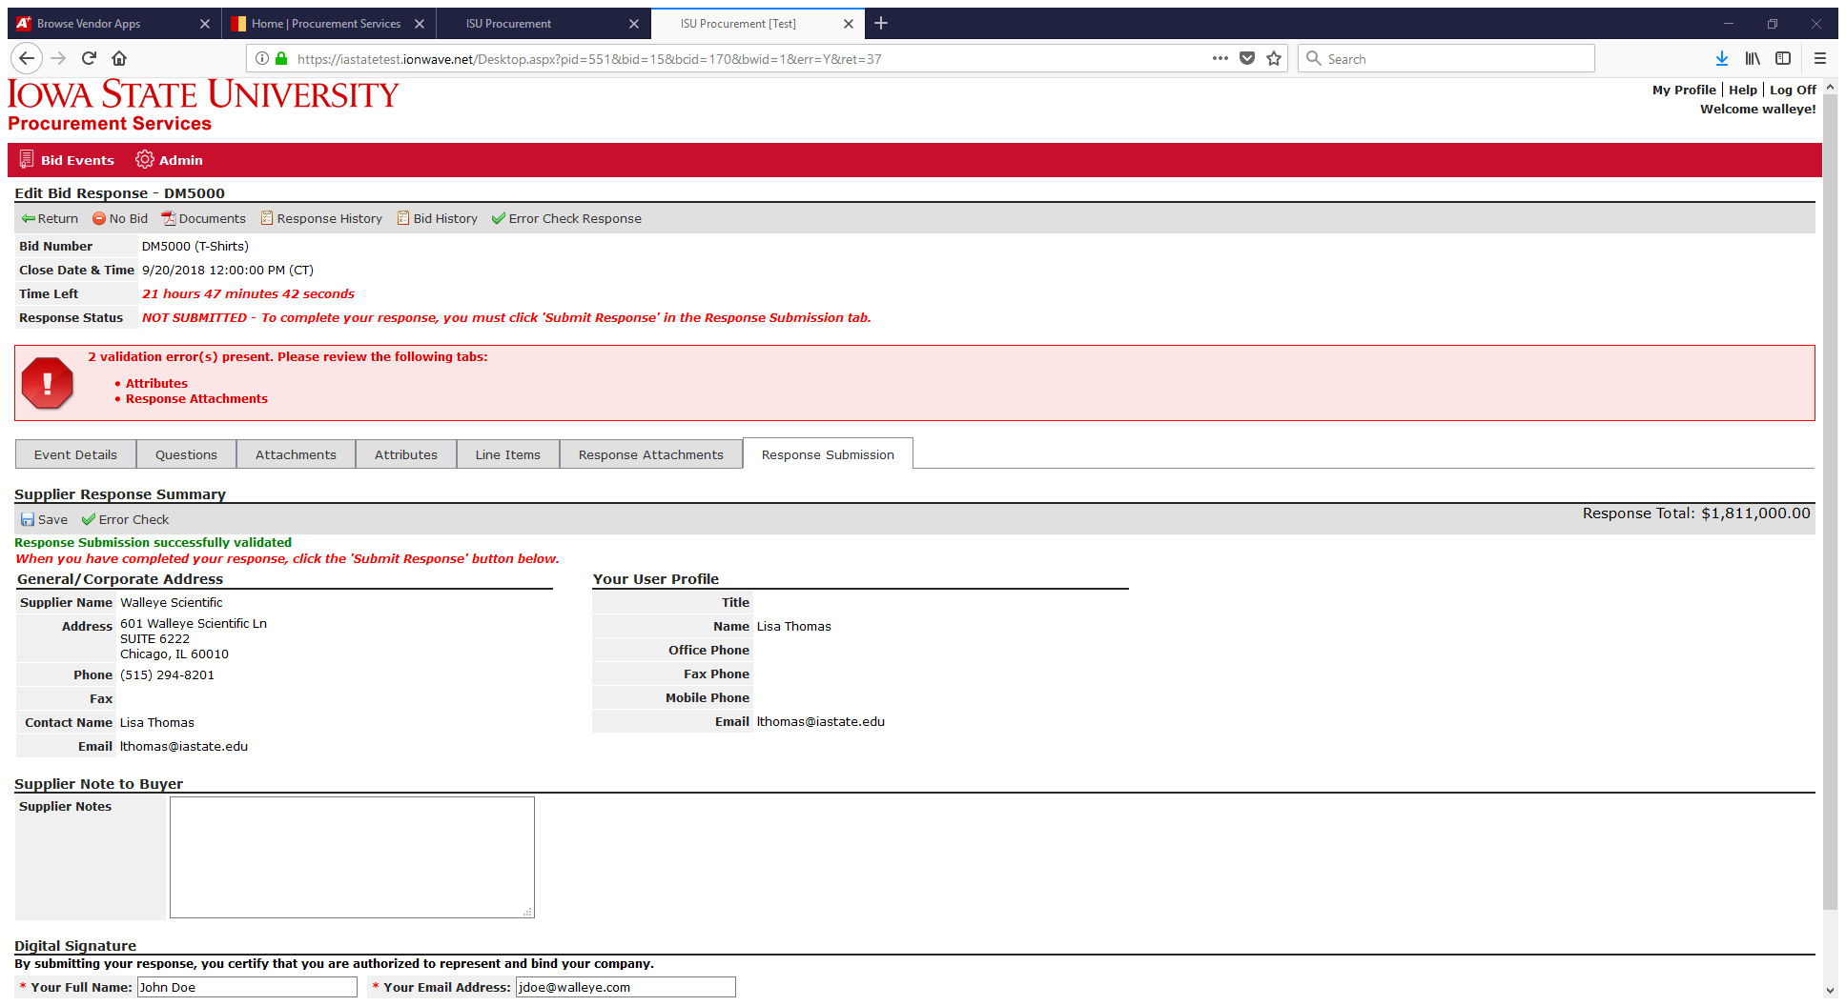

Successful Submission
A successful response submission will be indicated in the Response Status field. It will display “Response Submitted” with a date and time stamp. An email notification will be sent to confirm the successful response submission.

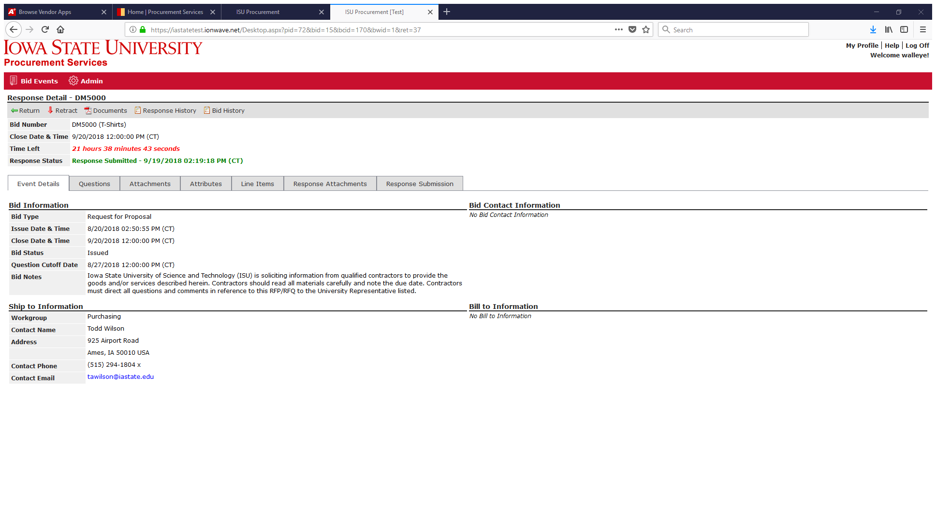

Response Retraction
If allowable, a submitted response can be retracted to withdraw the bid entirely or to edit and resubmit the bid. Select from the top toolbar.

After retracting, the response status of the bid will change to “NOT SUBMITTED”. Navigate the tabs to make your desired changes, then go to the Response Submission tab to submit your revised response before the due date and time.
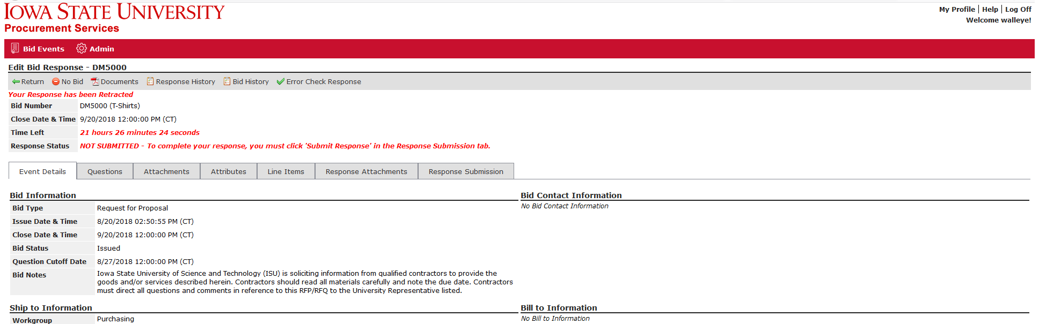

Important Note: A retracted bid response is no longer considered “submitted.” The supplier MUST resubmit a retracted bid response to considered.

